BIOC 404 Cygler 6th Lecture Wed Apr 5th

Recap/Continuation from last lecture:

So we looked at the experimental setup of X-ray crystallography/diffraction, how we obtain a crystal and how we measure the scattering from the protein crystal. The process of obtaining a crystal is straightforward as we just follow a recipe; however, the outcome is not guaranteed and very often we need to learn more about our protein: what it likes, dislikes, how it behaves in different conditions and determining the best precipitating agent… basically we have to make the protein happy

It is important that the crystal is as pure as much as possible and that it is in a solution with only one type of particle. For instance, if our protein has a tendency to aggregate then what we have in solution will be clumps of various sizes; monomers, dimers, trimers, very huge complexes. Thus we have a situation in solution where we have many different particles that look different and we want to somehow get them to form an array, but that is not possible. Very often we have equilibrium between the different forms, and this can be influenced by the experimental conditions: presence of salt, pH we are working in and buffers.

So we have to look at the purity and conditions that promote the presence of only one type of particle. Gel filtration can help us determine this easily. For example if we run a gel filtration and obtain several peaks, we can take the larges peak and re-run it and then use it for crystallization. In addition, Dynamic or Static Light Scattering may be used to tell us the distribution of particle sizes: a monomer will have a smaller gyration rate than a dimer or trimer. We can then change the conditions and study the aggregation state. In the lab, three or four hundred different conditions are tried routinely. Since we have small volumes, drop sizes are less than one microlitre, so even with protein concentrations of 5-10 mg/ml, with 1 mg of protein we can set quite an amount of trials; the lower the volume, the more trials you can set up with the same amount of protein.

Synchrotrons

With the home source:
- We have electrons running through to a piece of metal, usually copper as its characteristic conditions are good.
- Electrons in the copper atom are excited
- When the electrons fall down from the excited state to the lower state they emit radiation that corresponds to the energy level between the two states.
- There is also some white radiation from electrons which are basically slowing down due to acceleration or decelerations
We get a background of white radiation with some spikes corresponding to the excitation level of the atom.

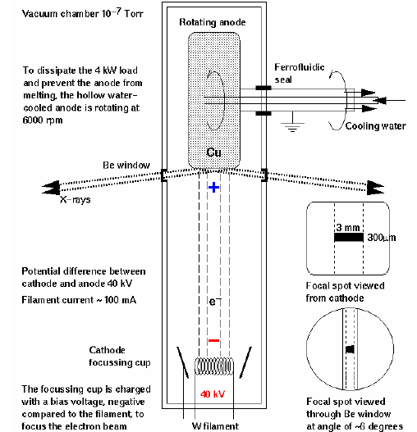
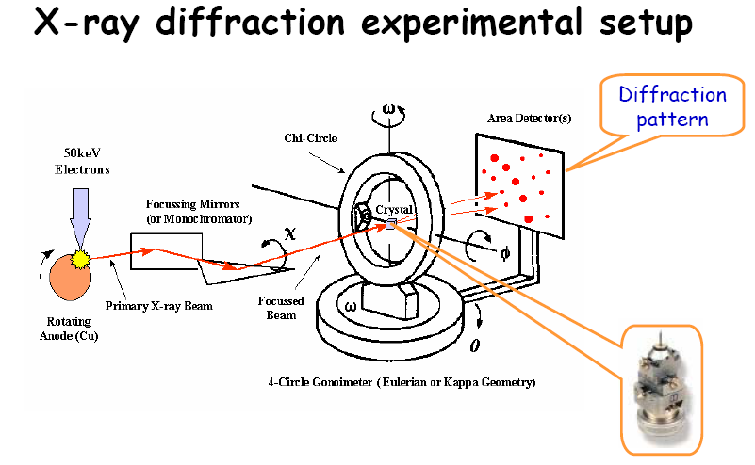
If you want very intense radiation then you have to have a very large stream of electrons heating this anode. The electrons running in the tube cause it to get warm and so if you run very energetic electrons, some of the energy is dissipated as x-rays but a lot of it is dissipated as heat. The metal (anode) is getting hotter and we have to cool it, but there is only a certain capacity of cooling we can do. Basically the intensity of the radiation really depends on how well we can cool this piece of metal. A rotating anode spreads the heat around the surface of the cylinder rather than having it at one point.

With Synchrotrons, we have electrons running around in an almost circular orbit, always changing direction, so there has to be some force applied on them. They emit radiation, and if they run fast enough, the radiation they emit is in the x-ray change. Due to having different speeds, they emit a whole spectrum rather than just a singe wavelength. This is 3 to 9 orders of magnitude stronger than what we can get in the labs (home source), and it depends on the design of the synchrotron.

We have to have a monochrometer that will select a single wavelength, the better it is the narrower the wavelength. We can tune the monochromoter so that we can select any wavelength we want from about .5 to 2 angstroms, again this depends on the type of synchrotron.

With the home source, where we feed electrons into a specific anode made of a certain metal, we get a characteristic radiation that corresponds to the energy level of the electrons in the atom. Thus we don’t have much leeway in selecting the wavelength. This can be done my changing the anode (a different metal would have a different characteristic wavelength), but we do not get a continuous spectrum.

Essentially, Synchrotrons:
- provide a much stronger beam than we can have with the home source (intensity).
- Intensity is in the range of .5 of 2 angstroms; we can select any wavelength we want (tunability).

Now on with lecture 6 …
Phase Problem
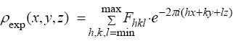
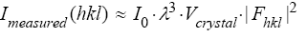
In order to obtain the electron density we need to carry out some sort of Fourier transform of the measured structure function. This structure function is non zero at the integers h, k and l; we can replace these integers by a summation over those points where the F is non zero.

What we measure in
the experiment is the intensity (I), which is proportional to the square of the modulus of the structure function as well as other factors such as the volume of the crystals. Larger crystals result in more electrons scattered, thus more unit cells obtained, and the shape function becomes sharper and bigger. So we would like to have good, large crystals. For example, take crystals that are 50 microns or 500 microns: the larger one is ten times larger in each direction, so the volume will be 1000 times larger. Such a crystal will diffract 1000 times stronger than the smaller crystal. The intensity also depnds on wavelength and the initial x-ray intensity.

So what we get from the experiment is the amplitude (or modulus) of the structure function. We don’t know the phase difference; phases are lost to us in the experiment and since the structure function we cannot go from the intensity to the density
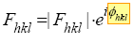
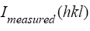

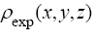

One way to possibly recover this is by applying the principles of holography, where we actually measure amplitude in phase.
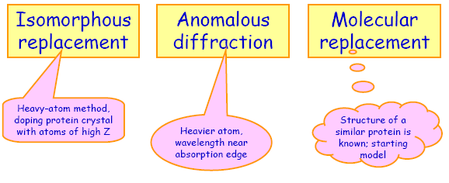
Solving the Phase Problem

We cannot go around the fact that we need to know the phase difference. Somehow we have to recover these phases and we have three methods of doings so.

i) Isomorphous Replacement:
- It was used in determining the structure of haemoglobin and myoglobin. Used up till mid 90s, where it was the only method by which we could determine new structures.

ii) Anomalous Diffraction:
- This relies on the specific properties of special atoms. It was never used to solve the phase problem mostly because it required very precise measurements which could not be extracted from recordings on film.

iii) Molecular Replacement:
- As we solve more and more structures we noticed that a lot of them were quite similar, and that we can make a prediction by looking at the aa sequences. With many thousands of structures available, the rule of thumb is to take 2 protein sequences that show 30% sequence identity or more, then there is a high probability that they will have a similar structure. They do not have to be similar as we have examples where we have very high identity but very different structures. We can predict a model based on the identity and we can it as a reference point to start from to overcome the phase problem.

Isomorphous replacement relies on doping a protein with a heavy metal (having a large Z) such as Hg or Pt. Doping means adding it to the crystal hoping that the atoms will bind in a very specific manner to each molecule such so that we have the additional atom forming a sub lattice in our crystal without disturbing the arrangement of protein atoms

Anomalous diffraction means that we are using the properties of the atom that electrons in the atom are not free; quantum mechanics principles apply and the electron can jump to the next orbital in a quantum jump, and not in a continuous spectrum. When the energy of radiation comes very close to the energy level between the two states the electron can jump to the upper level and then fall back. When we are very close to that difference in energy, we have a dissipation of energy and the absorption of energy by this atom increases.

Isomorphous Replacement

We have our proteins and we dope with a heavy atom that binds specifically to a molecule and together we have a situation where the protein contains heavy atom.
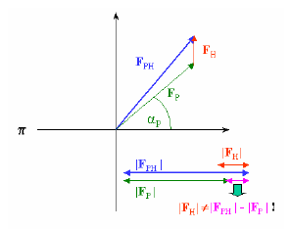
We have metal binding sites in proteins, such as iron in haemoglobin and myoglobin, cysteins form very good ligands for mercury and little spaces in proteins where xenon can get in very easily and be very content. Also, we can modify proteins by a chemical reaction to attach iodine to a tyrosine or modify cystein groups. If we can attach the heavy atom to a specific protein without disturbing the protein, then the scattering of PH(protein + heavy atom) will be scattering of P(protein) plus H(heavy atom). This would be a vectorial addition of 3 complex functions. Basically H will be contributing to the scattering of P to form PH. We end up with a triangle and if we take the sum of the length of the two component vectors, it doesn’t have to be the same as the final vector magnitude, but we can assume otherwise.

So we can make this approximate assumption, and if we measure the length of Fp and Fh , we have some estimate of the length of Fph. We now have a case where we roughly know the amplitude of Fph (and in effect the intensity).

With relatively small numbers of atoms in the unit cell, we have developed methods to allow us to figure out where these atoms are located. There are very good statistical methods for small molecules or cases where there few atoms that allow us to determine the structure without bothering with much more experiments. We make a quantum jump such that we have a situation where we are assuming somehow we found out where these guys (heavy atom derivatives) are located which means that we can calculate Fh as a scattering amplitude and we can get the phase so we know the modulus and the phase …

Notes: Fh is not purely imaginary, it is a complex number with real and imaginary components. Scattering by an atom with more electrons will scatter so much stronger as scattering is proportional to the amplitude, which is why heavy atoms are used.
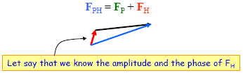
Now we know the length of Fh and its direction (the vector), and we also know the length of Fp and Fph. How can we recover the triangle knowing these 3 things ?

We construct a triangle as shown and we draw two circles, one with radius Fp and the other with radius Fph (the bigger circle), and we can see that we have two possible geometric solutions, but we know that only one of the two is correct because our scattering amplitude has only one phase.

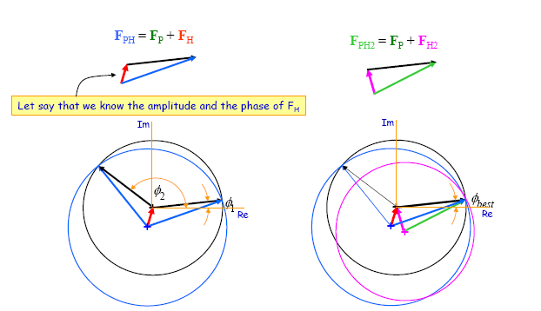
What we do is we find another heavy atom derivative and dope our protein with it, for eg with gold rather than mercury, to get another case where we have two geometric solutions, but with the same Fp, since the protein structure didn’t change. We end up with different heavy atoms with different locations in the protein and so we have a different amplitude of scattering (Fh). We do a similar construction and superimpose it over the previous construction. We end up with three circles, one for Fp (which is the same in both cases) and one for each Fph. All three circles will intersect at one point corresponding to the right answer.
Before this data, the phase solution could be anywhere from 0 to 360. Using one derivative, we narrowed it down to two potential solutions, and with two derivatives we narrow it down to just one geometric solution.

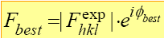
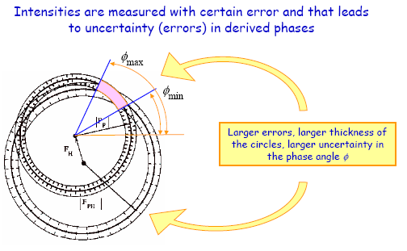
Finally we can plug in the values of the scattering amplitude derived from the integers h, k and l, and the phase to get a best value of F. But in reality it’s more complicated: we have uncertainty in our amplitude such that instead of drawing one circle we have to construct our circles as shown, and they would intersect over areas rather than points. In the end we narrow down our solutions to a range of values with uncertainty.

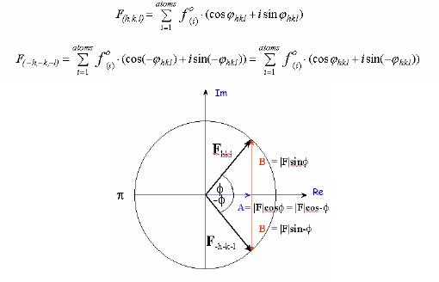
The difficulty lies in identifying the heavy atom derivative that we can add to the crystals without destroying them, and that will attach to a specific position in the protein without disturbing the protein atoms. Thus we need to soak our protein in different solutions to determine a good isomorphous derivative and so a solution of a structure may take several years.

Friedel Pair Relationship

For the mathematically inclined, the prof asked the following: How do we obtain a real number (the electron density) from complex functions. How does all this summation result in a real function, where the imaginary component of that term is zero?

The answer lies in the following:
Lets take a structure factor corresponding to h, k, and l. Basically we have a summation over all the atoms. Lets examine the F value corresponding to integers –h,-k, and -l
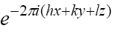
Looking at this equation, and plugging in the negative integers, we end up with a negative value of the phase (essentially opposite in sign). This reflection in F will have the same real component but will have an imaginary component that is opposite in sign but with the same value. Same modulus of scattering, same intensity, only the angles will differ.
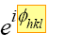
By using Euler’s theorem, and knowing that cos (-x) = cos (x) and that sin (-x) =
-sin (x), we can see that the real component (which corresponds to cos) will remain the same whereas the imaginary component (corresponding to sin) will have the same length but will be reflected. Look at the slide at the bottom of the previous page and examine the first equation and the right hand side of the second equation to see that the only difference between the two is in the sign of the sin function.

So, by grouping the two summations, that of h, k, l and of –h, -k and –l, we end up with a real number since the imaginary components of the two summations have opposite signs and will essentially cancel each other out (leaving only the real component).

Scattering amplitude near absorption edge

All this works really well if we have free electrons, but that is not the case as we know that electrons within atoms are not free, they are bound and can be excited to higher energy levels.

Looking at the energy of x-rays, proportional to the frequency. For lambda of around 1, it is pretty close to the absorption edges.
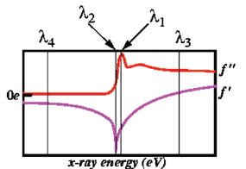
If we look at heavier atoms (Hg) the difference between the lowest and another level is sort of in the range of lambda of about 1. This shows the importance of synchrotons, any of these wavelengths are available, and we can tune our search exactly to being at this energy of the x-ray corresponding to a specific energy level in the atom. If we want to look at iron, its excitation level is at a slightly different energy, so we can tune our wavelength such that we are now in the range where we can excite the iron atom. So some electrons can be excited to a higher level but then fall back to a lower level, emitting a photon with the same energy that excited them. Since this is not simultaneous, it introduces a time delay which in turn causes a phase change to the wave that scattered from these electrons that went up and then came down. The phase difference from this anomalous part (called so because they do not correspond to free electrons, i.e. anomalous contribution) to the real part is 90 deg. This contribution is imaginary, and has a slight contribution to the real number.

The structure can be described by such a function, and this change can be quite large.
By changing the energy, we are changing the scattering from some atoms that are inside our crystal.

This still requires some doping, which is achieved by changing the S to Se, forming recombinant proteins containing selenomethionines,. The main point is that basically this heavier atom at one wavelength behaves one way, and then at a different wavelength it looks taller, (like more electrons). Therefore, we have an internal marker that becomes more visible when we tune the wavelength to see it.

With Isomorphous replacement, we are measuring scattering with different crystals that have different heavy atom derivatives, and thus possibly different conditions. With this method, we can measure the scattering at different wavelengths using the same crystal, thus eliminating systematic errors.

What this anomalous effect means is that when we are at this very narrow range of wavelengths where we excite the atoms, the Friedel law breaks down. Scattering from h, k, and l and from its reflection are no longer the same. The reason comes from the fact that the anomalous scattering is always at 90 degrees in both cases, thus breaking down the mirror symmetry, and the dark vector (below) is no longer the same in the two reflections.

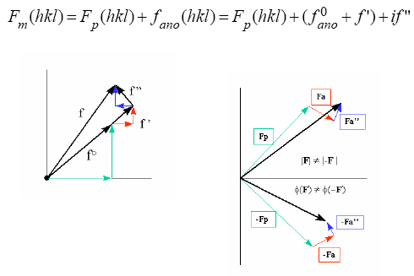
We can think of this as sort of an isomorphous replacement. We have a difference that we can measure, and we can measure at wavelengths where this effect does not occur.

And finally we can make a construct that is similar to what we had before with the case of two heavy atom derivatives, only slightly more complicated.

